

Risk management PLAN

  - Riskiness index
 | ITrustU |  | Your Confidence, our commitment



Executive Overview
The COVID-19 pandemic has introduced pressures our existing risk management plan must now address, alongside ongoing threats from cyber and economic areas. A risk management plan allows us to anticipate these disruptions, protect our obligations to stakeholders, and direct resources to where they reduce our exposure most.
The riskiness index is the first stage of our pandemic risk management plan. It assesses our current exposure across four areas: Finance, Infrastructure, Reputation and Marketplace (FIRM). Our overall riskiness index is 55 out of 80. Marketplace carries the greatest exposure (15), followed by Reputation (14) and Infrastructure and Financial (13 each). Our clearest strength is the availability of funds, as supported by Tiva and our strong market share while our greatest exposures lie in internal controls, reserve adequacy, and IT capacity. This index will guide our immediate response, help prioritize resources, and inform the crisis leadership team in coordinating the implementation of the pandemic plan.




Background and purpose
ITrustU operates from Mississauga, Ontario, as part of the Tiva insurance group, providing insurance and pension products to individuals and small businesses. Our core operations include policy sales, premium collection, claims processing, customer account management, and the investment of premiums to support operating costs and claim payments. These activities depend on our employees, technology systems, and third-party service providers.

The COVID-19 pandemic has introduced challenges that our existing risk management plan did not anticipate. We must assess how changes in staff availability, working arrangements, customer needs, and economic conditions affect our ability to maintain operations and meet our obligations to policyholders. These pressures exist alongside ongoing threats such as cyberattacks, technology failures, and disruptions to third-party services.

Our plan focuses on four elements of the organization using the FIRM framework: Financial, Infrastructure, Reputation, and Marketplace. As the first stage of our pandemic risk management plan, this riskiness index assesses our current exposure within each element. The findings will help guide our immediate response, prioritize resources, and support the crisis leadership team being established to coordinate pandemic plan implementation.

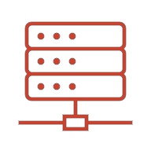    INFRASTRUCTURE  FINANCIAL |  |  | MARKETING  REPUTATION    

Financial Risk
FUNDING ALLOCATION

ItrustU belongs to Tiva, the sixth largest insurance group in the world. It collects premiums in advance from a very large customer base in Ontario that gives it a steady flow of investable funds. The pandemic creates some critical new funding needs: a crisis leadership team and a pandemic plan. Beyond that, there is a need to put measures in place to reduce exposure to various risks in the present and beyond. Premiums are invested in assets like Canadian stocks, bonds, real estate and precious metals to cover the cost of business and insurance claims. ItrustU also holds two kinds of liability: short-term Property & Casualty (P&C) claims like car, home, and travel, and long-term life and pension obligations.

Given our portfolio, there is a good chance that ItrustU would have liquidity problems as equities, real estate and precious metals are volatile assets and slow to sell. In times of crises, P&C claims need cash quickly to pay out to claimants. Stocks and precious metals can be sold quickly but the risk with them is being forced to sell at a loss during a downturn. To combat a worsening economy, it is reasonable to anticipate a cut in interest rates to drive investment, which could also affect longer product plans. Since every holding is Canadian, any regional or national dip will hit both assets and claims at the same time. There is a risk that bank partners could delay or not remit premiums altogether or reinsurers would not be in a position to pay recoveries and bond issuers may default on any dividends they expected to receive.

We are also concerned about where funds are dedicated. Cyber is listed as one of the main risks the company plans to mitigate against yet has no dedicated cyber-security staff. The current assessment is that resources appear disproportionately distributed to the risks that the company is concerned with. On paper, the company, in its current position and standing, will be able to treat most financial vulnerabilities in a pandemic economy, depending critically on how quickly they can move their assets.

INTERNAL CONTROLS

ItrustU currently collects all premiums, processes claims and quotes through their website, mobile app and internal systems. As a result, they are susceptible to a litany of cyberattacks that can have significant financial implications: direct theft through fraudulent claims payouts and payroll diversion; ransomware and recovery costs; data loss and its legal costs; regulatory penalties; a tech outage would stop premiums collection and claims payment at the same time. Six people currently cover IT and networking for 50 desktops, on-site servers and the internal network. Hosting, backups and security advice are outsourced. A six-person team likely cannot provide round-the-clock monitoring. Control therefore depends on vendors the company does not directly manage. The switch to remote work during a pandemic increases the likelihood of vulnerability and decreases the strength of defending it.

LIABILITY MANAGEMENT

ItrustU writes both P&C and life/pension products. In the industry, reserves are typically the largest liability on the balance sheet. With one in three Ontario households insured, adverse weather conditions like ice storms or floods will affect a large share of the clients at once. In July 2013, Ontario recorded a record rainfall that insurers coughed up $940m to reimburse—making it the most expensive insured natural disaster in Ontario’s history. Given the liquidity issues mentioned above, any reserve or float they’re required to have may not be able to cover paying out large claims. Travel, medical, and cancellation claims are all going to rise at the same time. Falling interest rates will also increase the value of pension and annuity obligations while reducing investment income; any increase in the value of pension will apply both to the company’s product and its own employees. The key for financial risk management here is to weigh the costs and benefits of liquidation of certain assets for immediate relief (even at a loss) to sustain the company independent of the health of the parent company or government intervention. Survival strategies may include taking on further liabilities to identify and create pathways for stable cash flow amid rising claims.

Finance Riskiness Index
CODE | DESCRIPTION | SCORE
1.1 | Lack of availability (or unacceptable cost) of adequate investment funds | 2
1.2 | Inadequate procedures for allocation of funds to available opportunities | 3
1.3 | Poor internal financial controls to prevent fraud and control credit risks | 4
1.4 | Insufficient reserves for existing and historical liabilities (including pensions) | 4
 | TOTAL FOR FINANCE COMPONENT | 13

Infrastructure Risk
PEOPLE SKILLS

The onset of the COVID-19 pandemic is changing our employees’ working routines and creating a need to adapt to remote working arrangements. Without an established plan for working from home, staff productivity may decline, reduced in-person interaction may create communication difficulties, and employees may struggle to resolve problems or access company resources. Illness and isolation may also reduce staff availability, while specialized roles in IT, claims processing, and customer support can be difficult to replace on short notice.

To reduce this risk, we should establish clear remote-work procedures as part of our pandemic response. These procedures should include appropriate tools, training, and secure access to company resources so that employees can continue performing their responsibilities effectively.

INADEQUATE EQUIPMENT

Pandemic-related restrictions may limit access to our buildings and equipment, creating challenges for employees whose work normally depends on office-based resources. Our current equipment includes approximately 50 desktop computers and only a few laptops, which will limit our ability to support widespread remote work. Providing suitable, company-managed equipment and secure access to our systems is therefore an immediate consideration. Our premises and on-site servers also require continued maintenance while access may be restricted.

To manage this exposure, we should assess employees’ equipment needs, prioritize essential roles, and establish procedures for distributing and supporting remote-work equipment. We should also arrange for essential maintenance and authorized access to our premises and servers during restrictions.

IT RESILIENCE

The transition to remote work increases our dependence on reliable technology and secure access to company resources. Without adequate safeguards, such as a VPN, secure file sharing, access controls, data loss prevention measures, and employee training, we may face greater exposure to cyber threats, data loss, and reputational damage. We should verify whether existing safeguards can support the scale and demands of remote work.

Our technology infrastructure includes on-site servers, an internal network, and an internet connection through an external provider. These dependencies may create service bottlenecks or points of failure as more employees connect remotely. A prolonged loss of IT or network services could severely disrupt claims processing, premium collection, and customer support.

IT resilience is the highest-rated risk within this infrastructure assessment. We should prioritize secure remote access, test system capacity and recovery arrangements, develop reliable and iterative auditing protocols, and ensure employees understand and follow security procedures.

PRODUCT AVAILABILITY

Our ability to provide insurance products and related services depends on functioning software, hardware, and communication systems. When a failure occurs, employees need to coordinate service restoration and investigate its cause. Remote working arrangements may make this coordination more difficult, particularly if key staff are unavailable or cannot access on-site equipment.

We also depend on third-party providers, including our internet service provider, cloud provider, security consultants, and mailing, printing, and shredding services. These organizations may face their own staffing shortages, operating restrictions, and financial pressures during the pandemic. This could result in delayed service schedules, reduced capacity, or temporary or permanent business closures. For example, disruption to our shredding provider could delay the secure disposal of confidential records, requiring us to arrange secure temporary storage and find an alternative vendor. We should assess critical suppliers’ ability to maintain services and identify suitable replacements in case existing providers can no longer meet our needs.

Our product mix may shift as travel restrictions reduce new travel insurance sales and changes in vehicle use affect automobile coverage needs. Enquiries about life insurance, home coverage, and pension plans may increase, although greater interest does not necessarily translate into additional sales. We should monitor new business, renewals, cancellations, and policy adjustments to identify changes in revenue and product concentration.

This assessment rates product availability risk as medium. Our service-based business model reduces our dependence on physical inventory, while cloud backup offers some protection against data loss. However, neither ensures uninterrupted service. We should establish crisis management and disaster recovery procedures suited to remote work and maintain reliable communication channels for coordinating our response.

INFRASTRUCTURE RISKINESS INDEX
CODE | DESCRIPTION | SCORE
2.1 | Availability or cost of people skills, competencies and experience | 4
2.2 | Inadequate premises, plant and equipment to support operations | 1
2.3 | Processes, including IT infrastructure, have insufficient resilience | 5
2.4 | Product availability inadequate, including supplier unreliability | 3
 | TOTAL FOR INFRASTRUCTURE COMPONENT | 13

Reputation Risk
PUBLIC PERCEPTION AND THE ITRUSTU BRAND

The initial phase of the pandemic is critical to our reputation. We may need to manage an increase in claims for certain products while transitioning employees to remote work. Travel insurance is a particularly sensitive area, as widespread travel cancellations could generate increased claims, enquiries, and disputes over coverage. With just over 50 employees, we may struggle to manage this sudden workload. Delayed responses and unclear explanations could damage customer trust.

Economic uncertainty and job losses may also place our customers under financial pressure. Some may seek to reduce their coverage, defer premium payments, or access retirement savings where permitted. We should provide clear information about available options and their consequences. Insensitive communication or inconsistent treatment could harm our reputation during a period when customers are already vulnerable.

ETHICAL AND CORPORATE RESPONSIBILITY

Misinformation surrounding the pandemic may create confusion about insurance coverage and our response to changing conditions. We should provide accurate, consistent information about policy terms, exclusions, and any changes to our services. Unclear or misleading statements could undermine trust and prevent customers from making informed decisions.

We also have a responsibility to consider employee well-being as working arrangements change. Moving suitable roles to remote work may help reduce exposure to illness, but the sudden transition may contribute to stress, isolation, and difficulties balancing work and personal responsibilities. We should assess the need for additional mental health support, regular check-ins, and flexible working arrangements. Insufficient support could affect employee well-being and confidence in our leadership.

REGULATION AND COMPLIANCE

The pandemic places additional pressure on our ability to meet compliance expectations while maintaining essential services. Increased workloads and staff absences may contribute to processing errors, delayed claims handling, and incomplete records. We should monitor these pressures and ensure that changes to our working arrangements continue to support our obligations.

Our equipment includes approximately 50 desktop computers and only a few laptops, meaning that our existing arrangements primarily support office-based work. A rapid transition to remote work may increase the risk of unauthorized access, inappropriate information sharing, or exposure of customer data if suitable safeguards are not in place. We should verify that remote access, company devices, and cloud services adequately protect confidential information. Failures in these areas could attract regulatory scrutiny and damage customer confidence.

PRODUCT QUALITY AND SALES SERVICE

The pandemic may change customer demand across our insurance and pension products. Reduced travel and vehicle use could lead customers to question their existing coverage or request adjustments. At the same time, concerns about health, household finances, and retirement savings may increase enquiries about life insurance, home coverage, and pension plans. We should be prepared to explain available options and maintain consistent service as customer needs change.

Staff shortages and remote working arrangements may affect our ability to provide timely advice, process policy changes, and resolve claims. Supply chain disruptions and labour shortages may also delay repairs or replacement services associated with home and vehicle claims. These delays could affect customers’ experience even when the underlying disruption occurs outside our organization.

We should communicate expected service timelines clearly, explain relevant coverage limits, and provide updates when delays occur. Failure to manage these expectations could lead customers to view our products and after-sales service as unreliable.

REPUTATION RISKINESS INDEX
CODE | DESCRIPTION | SCORE
3.1 | Poor public perception of the industry and/or organization brands | 4
3.2 | Insufficient attention to ethics and corporate social responsibility | 3
3.3 | High regulator involvement and compliance expectations | 3
3.4 | Concerns over product quality and/or after sales service | 4
 | TOTAL FOR REPUTATION COMPONENT | 14

Marketing Risk
REVENUE AND INVESTMENTS

The onset of the pandemic places pressure on both our premium revenue and investment returns. Economic uncertainty may reduce customers’ ability to purchase or maintain coverage, while travel restrictions could sharply reduce demand for new travel insurance policies. Reduced vehicle use may also lead customers to request premium adjustments or explore less expensive coverage.

Our small business clients may face reduced revenue, temporary closures, and difficulty meeting ongoing expenses. These pressures could lead to requests for premium deferrals, coverage reductions, or cancellations. Business owners may also experience a loss of household income that affects their personal insurance and retirement contributions.

Our investment portfolio includes Canadian stocks and bonds, real estate, and precious metals. Market volatility could reduce asset values, while lower interest rates may reduce the income available from new fixed-income investments. These conditions could affect our ability to generate sufficient returns to support operating costs and insurance obligations. Our investment portfolio also requires review as market conditions change. Lower investment income and potential liquidity needs may affect how we allocate funds. Any proposed adjustments should be assessed against our claims obligations, liquidity requirements, and risk appetite, with the detailed analysis addressed in the financial component.

We assess this risk as high. While our range of products provides some diversification, we cannot determine how much protection our reserves provide.

COMPETITION AND CHANGING TECHNOLOGY

The pandemic increases the importance of accessible digital services as customers and employees reduce in-person interactions. Customers may favour insurers that offer convenient online purchasing, policy changes, claims submission, and support. Competitors able to adapt quickly could attract customers who experience delays or limited service through our channels. Reduced vehicle use may also increase interest in flexible pricing and usage-based insurance. We should assess whether our products and systems can respond to these changing expectations.

Our website and mobile application provide an existing digital presence. However, our reliance on approximately 50 desktop computers, only a few laptops, and on-site systems may constrain employees’ ability to support these channels remotely. Having customer-facing technology does not necessarily mean that our underlying processes can accommodate increased online demand.

Given that the high speed of change may exceed our current capacity to adapt. Our existing digital channels provide a foundation, but we must assess their functionality, capacity, and integration with remote working arrangements.

ECONOMIC HEALTH AND POLITICAL STABILITY

The pandemic threatens Canadian economic activity through business restrictions, employment disruption, and reduced consumer spending. These conditions may affect customers’ ability to pay premiums, increase requests for payment flexibility, and reduce demand for new policies. Our concentration in Ontario and investments in Canadian assets expose us to related pressures across our customer base and investment portfolio.

Canada’s established political institutions provide a measure of stability. Government support may also help households and businesses maintain income and meet financial obligations, although its reach and effectiveness remain uncertain at this stage. However, given the global nature of our parent organization, sovereign economic health could severely impact its operational functionality.

We assign significant economic uncertainty alongside a comparatively stable political environment. This rating requires ongoing review as the duration of restrictions, employment conditions, global response, and effectiveness of support measures become clearer.

SUPPLY CHAINS AND MATERIAL COSTS

Although we do not manufacture physical goods, we depend on external service providers and the availability of materials and labour needed to settle certain claims. Pandemic disruption may therefore affect both our operating capacity and claims costs.

Given the identified risks that exist for our third-party vendors, such as staffing shortages, reduced capacity, or business closures, that may occur at the same time that our reliance on their services continues, disruption could interrupt customer service, delay policy administration, or require us to secure alternative vendors at additional cost.

Property and vehicle claims may also depend on repair services, inspections, replacement parts, and construction materials. Restrictions and shortages could delay settlements or increase costs beyond the assumptions used when policies were priced.

These disruptions may affect several dependencies simultaneously. Alternative providers may be available, but replacement arrangements can take time, and widespread shortages may limit our options.
MARKETING RISKINESS INDEX
CODE | DESCRIPTION | SCORE
4.1 | Insufficient revenue generation or inadequate return on investment | 4
4.2 | Competitive marketplace and/or rapidly changing product technology | 4
4.3 | Poor sovereign economic health and/or lack of economic or political stability | 3
4.4 | Complex supply chain and/or unpredictable raw materials costs | 4
 | TOTAL FOR MARKETING COMPONENT | 15

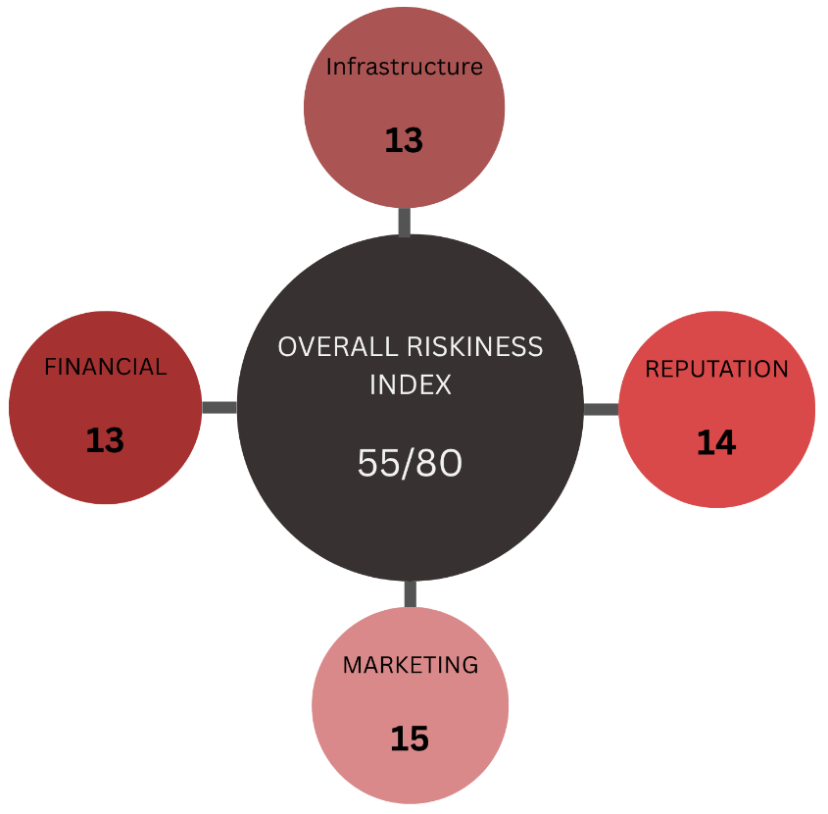

Overall risk assessment
Our riskiness index totals 55 out of a possible 80, comprising Financial risk at 13/20, Infrastructure at 13/20, Reputation at 14/20, and Marketplace at 15/20. This indicates substantial exposure across the four components, with many individual risks rated medium or high. Marketplace has the highest component score, reflecting pressure on revenue, changing customer expectations, digital competition, and supplier disruption. IT resilience receives the highest individual rating at 5/5 and requires immediate attention.
These risks are closely connected. Technology failures, cyber incidents, staff shortages, or vendor disruption could interrupt claims processing and premium collection while compromising customer information and trust. At the same time, investment volatility, reduced premium income, and claims obligations may place pressure on liquidity and reserves. Delayed
service or unclear coverage explanations could further damage our reputation and customer retention.
Our priorities should therefore be to strengthen secure remote working and internal controls, assess liquidity and reserve adequacy, support essential staff, and confirm continuity arrangements with critical suppliers. Clear customer communication and adaptation to changing demand are also necessary. Targeted investment in people, systems, and vendor oversight should guide the next stage of our pandemic risk management plan, with scores reviewed as conditions and available information change.




